Business Report

This report will place a focus on analyzing rental trends for movies based on their popularity broken down by title and genre. This will give stakeholders an understanding of which movies attract the most rentals and which genres perform well, informing future inventory and marketing decisions.

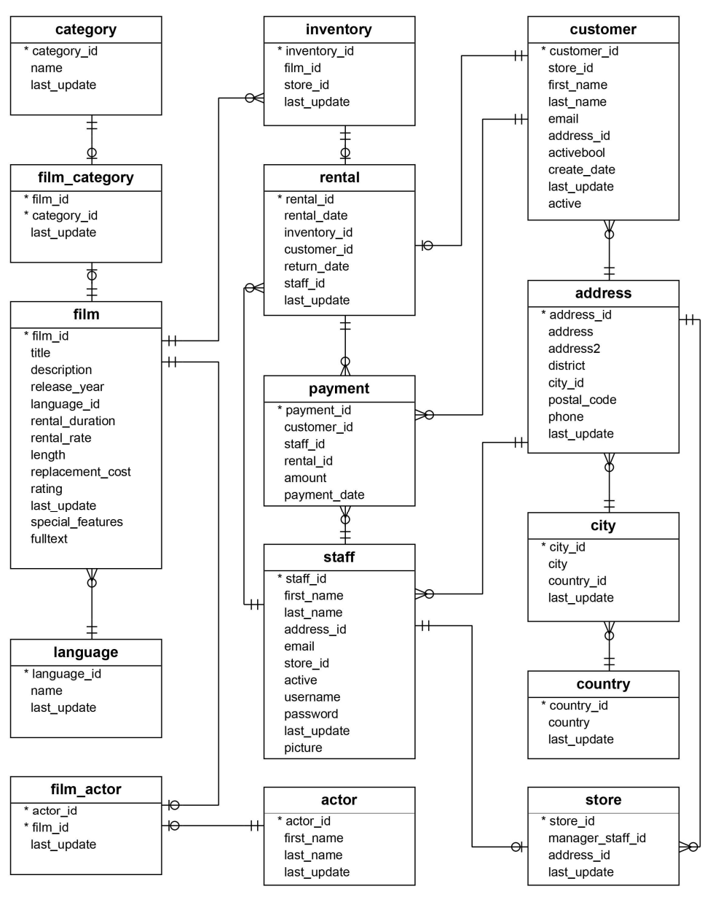

A1. Identify the specific fields that will be included in the detailed table and the summary table of the report.
Detailed table fields (most_rented_movies)
- title - movie title
- genre - movie genre type
- Number_of_rentals- total count of rentals for movie

Summary fields (top_rentals)
- Title - title of movie
- number_of _rentals- total count of rentals for movie

A2. Describe the types of data fields used for the report
- Title- VARCHAR
- Genre- TEXT
- Number_of_rentals - INT

A3. Identify at least two specific tables from the given dataset that will provide the data necessary for the detailed table section and the summary table section of the report.
- Film- provides us with the title
- Rental - provides information about each rental which would include the total number of rentals for a movie

A4. Identify at least one field in the detailed table section that will require a custom transformation with a user-defined function and explain why it should be transformed (e.g., you might translate a field with a value of N to No and Y to Yes).

- I can use a transformation on the title field and ensure that all movies are capitalized

A5. Explain the different business uses of the detailed table section and the summary table section of the report.
- Detailed Table (most_rented_movies): Provides rental activity by both title and genre, helping inventory managers understand which movies and genres are most popular.
- Summary Table (top_rentals): Summarizes the most rented movies by title only. This will be helpful for a quick insight on the top rentals without genre.

A6. Explain how frequently your report should be refreshed to remain relevant to stakeholders.

The report should be refreshed monthly. This frequency provides stakeholders with up-to-date insights into rental trends. Monthly updates will help stakeholders see trends in movie and genre popularity, aiding inventory planning and marketing.

B.
CREATE OR REPLACE FUNCTION capitalize_movie_title (movie_title VARCHAR)
RETURNS VARCHAR
LANGUAGE plpgsql AS $$
BEGIN
RETURN INITCAP (movie_title);
END;
$$;

C.

detailed table

CREATE TABLE most_rented_movies(
Title VARCHAR (50),
Genre TEXT,
number _of_rentals INT
);

Summary table

CREATE TABLE top_rentals(
Title VARCHAR (50),
Number_of_rentals INT
);

D

INSERT INTO most_rented_movies (title,genre,number_of_rentals)
SELECT
capitalize_movie_title(f.title) AS title,
g.name AS genre,
COUNT (r.rental_id) AS number_of_rentals
FROM film f
JOIN inventory i ON f.film_id = i.film_id
JOIN film_category fc ON f.film_id = fc.film_id
JOIN category g ON fc.category_id = g.category_id
GROUP BY f.film_id , f.title , g.name
ORDER BY number_of_rentals DESC;

E.

CREATE OR REPLACE FUNCTION update_top_rentals()
RETURNS TRIGGER
LANGUAGE plpgslq AS $$
BEGIN
DELETE FROM top_rentals;
INSERT INTO top_remtals
FROM most_rented_movies
GROUP BY title, number_of_rentals
ORDER BY number_of_rentals DESC
RETURN NEW;
END;
$$;

CREATE TRIGGER trg_update_top_rentals
AFTER INSERT OR UPDATE ON most_rented_movies
FOR EACH STATEMENT
EXECUTE FUNCTION update_top_rentals();

F.

CREATE OR REPLACE PROCEDURE refresh_data()
LANGUAGE plpgsql AS $$
BEGIN

–clear data–

DELETE FROM most_rented_movies;
DELETE FROM top_rentals;

–repopulate–

INSERT INTO most_rented_movies (title,genre,number_of_rentals)
SELECT
capitalize_movie_title(f.title) AS title,
g.name AS genre,
COUNT (r.rental_id) AS number_of_rentals
FROM film f
JOIN inventory i ON f.film_id = i.film_id
JOIN film_category fc ON f.film_id = fc.film_id
JOIN category g ON fc.category_id = g.category_id
GROUP BY f.film_id , f.title , g.name
ORDER BY number_of_rentals DESC;

- A job scheduling tool that can be used is Agent PgAgent

